UNIT-3

ELECTRICAL DISTRIBUTION SYSTEMS

An electric power system has three important components.

i) Generation system ii) Transmission system iii) Distribution system

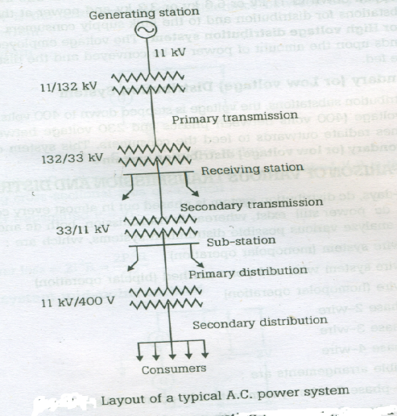

The electrical energy produced at generating station is conveyed to the consumers through the network of transmission and distribution systems at different voltages.

The part of power system which distributes electrical energy for local use is known as distribution system. In general it lies between substation fed by the transmission system (or a local generating plant) and consumer meters.

Elements of distribution system:

A distribution system can be subdivided into i) Feeders ii) Distributors iii) Service mains

i) Feederes:

It is a conductor which connects the substation (or localized generation station) to the area where the power is to be distributed. Generally no tappings are taken from this feeder.

* Current in the feeders remains same throughout the feeder as no tapings are taken from it.
* Feeders are designed based on its current carrying capacity.

ii) Distributors:

It is a conductor from which tappings are taken to supply consumers.

* So the distributor does not carry same current throughout its length.
* Distributors are designed based on its voltage drop along its length.

iii) Service mains:

It is a small conductor/ cable which connects the distributor to the consumer terminals.

**Classification of distribution systems**:

1) According to nature of current:

a) DC distribution system : Types: i) 2-wire dc system ii) 3-wire dc system

b) AC distribution system.

Generally Ac distribution is used. Where as in some applications dc supply is absolutely necessary like for the operation of variable speed machinery (i.e. dc motors), for electro chemical work andfor congested areas where storage battery reserves are necessary.

2) According to type of construction:

a) Overhead system b) Underground system

The choice between these two systems depends on various factors like,

i) Public safety, ii) Initial cost, iii) Flexibility, iv) Faults occurance, repairs, v) Appearance, vi) Current carrying capacity & voltage drop, vii) Useful life, viii) Maintenance cost, ix) Intereference with communication circuits

3) According to scheme of connection:

a) Radial system b) Ring main system c) Interconnected system

4) According to number of wires:

a) Two wire system b) Three wire system c) Four wire system

The AC distribution system is divided into two parts.

i) **Primary or High voltage distribution system**:

The system which conveys electrical energy to various distribution substations and to the bulk power consumers (at the voltage rating of 11KV or 6.6KV or 3.3KV) is called primary or high voltage distribution system. This system operates at voltages somewhat higher than general utilization and handles large block of electrical energy. The voltage for primary distribution depends upon the amount of power to be conveyed and the distance of substation required to be fed. Generally primary distribution is carried out by 3-phase, 3- wire system.

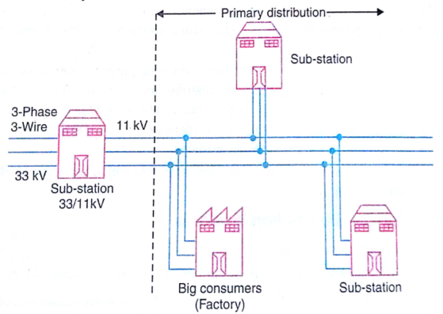

ii)**Secondary or Low voltage distribution system**:

The system which feeds electrical energy to various consumers at low voltages (400V between phases or 230 V between phase and neutral) from distribution substation is called secondary or low voltage distribution system.At each distribution substation the voltage is stepped down to 400V and power is delivered to the consumer through 3-phase, 4-wire system. The single phase domestic loads are connected between any one phase and the neutral, where as 3-phase, 400V motor loads are connected across 3-phase lines directly. Ex: Rice mills

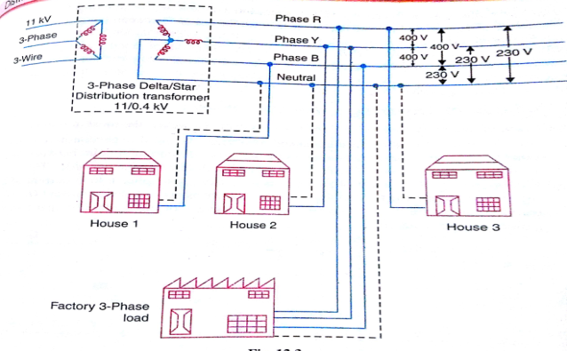

**Calculation of voltage drops in distributors:**

1) DC distributor fed at one end with concentrated load:

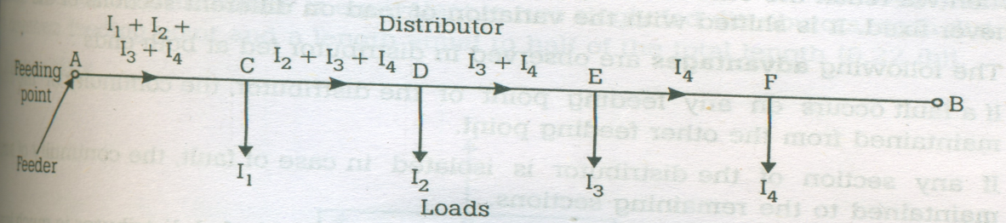

Distributor fed at one end with concentrated loading

Consider the single line diagram of two wire DC distributor AB fed at one end A and having concentrated loads I1, I2, I3, I4tapped at points C,D, E, F respectively as shown in above figure.

Let RAC, RCD, RDE, REF are the resistances of distributor sections AB,BC, CD, DE and EF respectively.

Then,

Voltage drop in section FB, VEF = I4REF

Voltage drop in section FB, VDE = (I3+I4)RDE

Voltage drop in section FB, VCD = (I2+I3+I4)RCD

Voltage drop in section FB, VAC=(I1+I2+I3+ I4)RAC

Total voltage drop in the distributor = VAC+VCD+VDE+VEF

= (I1+I2+I3+ I4)RAC+(I2+I3+I4)RCD+(I3+I4)RDE+I4REF

The minimum potential occur at point F, which is farthest from feeding point A, VF

= VA – voltage drors in sections AC, CD, DE, EF

= VA – [(I1+I2+I3+ I4) RAC+ (I2+I3+I4) RCD+ (I3+I4) RDE+I4REF],

In two wire DC distribution systems, two wires (go and return wire) are employed and hence the voltage drop will be voltage drop in both the wires.

2) DC distributor fed at both the ends with equalvoltages and concentrated loading:

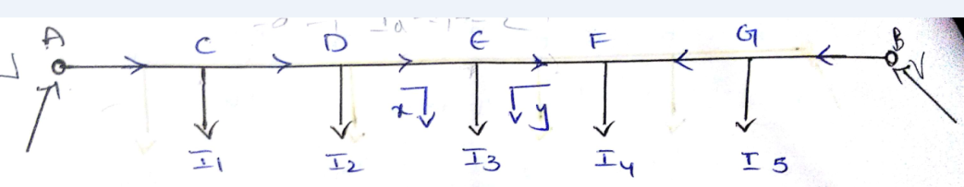

Consider a distributor AB fed at both the ends with equal voltages ‘V’ volts & having concentrated loads I1, I2, I3, I4, I5 at points C,D,E,F,G respectively.

Let RAC,RCD, RDE, REF, RFG, RGB are the resistances of distribution sections AC,CD,DE,EF,FG,GB respectively.

As we move away from one of the feeding points A, the potential goes on decreasing till it reaches minimum at some load point and then again rises and becomes volts as we reach the other feeding point B. The point ofminimum potential depends on the variation of load on the distribution sections.

* Let E be the minimum potential point in the above distributor, Then the loads between A and E

are supplied from feeding point A, and in between B and E are supplied from feeding point B.

* The load at minimum potential is supplied from both the ends.

Let IA amperes current is flowing from feeding point A then the currents in various section of the distributors are given below.

|  |  |  |
| --- | --- | --- |
| Section | Current in section | Voltage drop in section |
| AC | IA | IARAC |
| CD | IA – I1 | (IA – I1) RCD |
| DE | IA –( I1 + I2 ) | ( IA – I1 - I2 ) RDE |
| EF | IA –( I1 + I2+I3 ) | (IA – I1 - I2 - I3 ) REF |
| FG | IA –( I1 + I2+I3+I4 ) | (IA – I1 - I2- I3- I4 ) RFG |
| GB | IA –( I1 + I2+I3+I4 + I5) | ( IA – I1 - I2-I3-I4 - I5) RGB |

Total voltage drop in distributor = IARAC+ (IA – I1) RCD + ( IA – I1 - I2 ) RDE + (IA – I1 - I2 - I3 ) REF + (IA – I1 - I2- I3- I4 ) RFG + ( IA – I1 - I2-I3-I4 - I5) RGB

= VA - VB = 0

From the above equation IA canbe calculatedand the minimum potential point can be found by observing the load point which is supplying from both the ends.

3) DC distributor fed at both the ends with unequal voltages and concentrated loading:

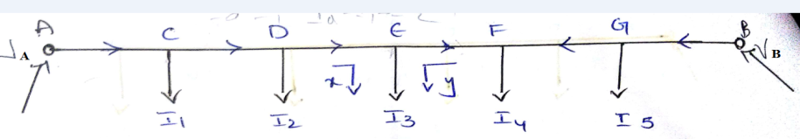

Consider a distributor fed AB fed at both the ends A and B with unequal voltages VA andVB respectively and having the concentrated loads I1, I2, I3, I4 and I5 at C, D, E, F and G points respectively.

Let RAC, RCD, RDE, REF, RFG, RGB are the resistances of distribution sections AC, CD, DE, EF, FG, GB respectively.

Let E be the minimum potential point at which the load is fed from oth the ends.

Let IA amperes current is flowing from feeding point A then the currents in various section of the distributors are given below.

|  |  |  |
| --- | --- | --- |
| Section | Current in section | Voltage drop in section |
| AC | IA | IARAC |
| CD | IA – I1 | (IA – I1) RCD |
| DE | IA –( I1 + I2 ) | ( IA – I1 - I2 ) RDE |
| EF | IA –( I1 + I2+I3 ) | (IA – I1 - I2 - I3 ) REF |
| FG | IA –( I1 + I2+I3+I4 ) | (IA – I1 - I2- I3- I4 ) RFG |
| GB | IA –( I1 + I2+I3+I4 + I5) | ( IA – I1 - I2-I3-I4 - I5) RGB |

Total voltage drop in distributor = IARAC+ (IA – I1) RCD + ( IA – I1 - I2 ) RDE + (IA – I1 - I2 - I3 ) REF + (IA – I1 - I2- I3- I4 ) RFG + ( IA – I1 - I2-I3-I4 - I5) RGB

= VA - VB

From the above equation IA can be calculated and the minimum potential point can be found by observing the load point which is supplying from both the ends.

4) DC distributor fed at one end with uniform loading:

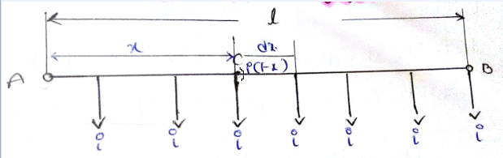

Consider a DC distributor fed at one end A and load uniformly with iA/m as shown in figure.

Let

Length of the distributor = ‘l’ m

Resistance of the distributor = r Ω/m (both for go and return conductors)

Current rating of the distributor = i A/m

Total current fed at point A = il A

Consider a point C at a distance of x m from point A.

The current flowing at point C = i(l-x) A

Consider a small length dx at point C.

Resistance of small length of the distributor = rdx Ω

Voltage drop over the length dx, dV =i(l-x)rdx

Total voltage drop in the distributor from A upto point C,VAC = 



The total voltage drop in a distributor , VAB= 

=  V =1/2 (il) (rl) = ½ IR (V)

Where I is the total current entering the distributor

R is the total resistance of the distributor

(From the above equation it can be seen that in a uniformly loaded distributor fed at one end, the total voltage drop is equal to the voltage drop produced by the whole of the load assumed tobe concentrated at the mid point.)

Power loss in element dx, dP = 

Total power loss in distributor, P = 

= 

=  = 

4) DC distributor fed at both ends with uniform loading with equal voltages:

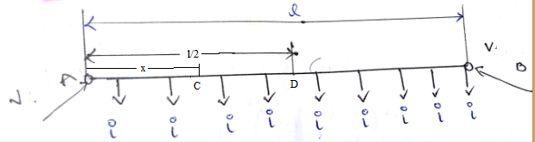

Consider a DC distributor fed at both ends with equal volatages and is uniformly loaded with i A/m as shown in fig.

As the distributor fed with equal voltages at both ends (i.e VA=VB), and is uniformly loaded, the minimum potential point ocuurs at the mid point of the distributor and the total current is supplied from both the feeders equally.

⇒Current supplied from feeding point A = il/2 A

Current supplied from feeding point B = il/2 A

Consider a point C at a distance of ‘x’ m from A

Current flowing at point C = 

Consider a small length dx of the distributor at point C, then

Voltage drop in the smallsection, dv = 

Where r is the resistance of distributor per meter

⇒ VAC = =

= = 

Let D be the minimum potential point (i.emid point of the distributor)which is at a distance of x/2 m from point A.

⇒VAD= V

Minimum potential, VD = VA - VAD= V - 

Power loss in element dx, dP = 

Total power loss in distributor, P = = = 

= W

5) DC distributor fed at both ends with uniform loading with un equal voltages:

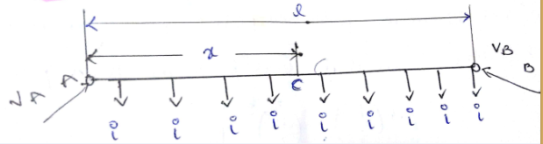

Consider a DC distributor fed at both ends with un equal voltages and is uniformly loaded with i A/m as shown in fig.

Let length of the distributor = l meter

Resistance of the distributor = r Ω /m

Let C be the minimum potential point where current enters from both ends of the distributor i.e it is the minimum potential point of the distributor.

Current supplied from feeding point A = ix A

Current supplied from feeding point B = i(l-x) A

Voltage drop in section AC =  V

Voltage drop in section BC =  V

Voltage at point C , VC = VA – Voltage drop in section AC

And also Voltage at point C , VC = VB – Voltage drop in section BC

⇒ VA - = VB - 

⇒VA – VB = = 

⇒Distance of minimum potential point from feeding point A, x = 

Ring distributor:

A distributor arranged to form a closed loop and fed at one or more points is called a ring distributor.

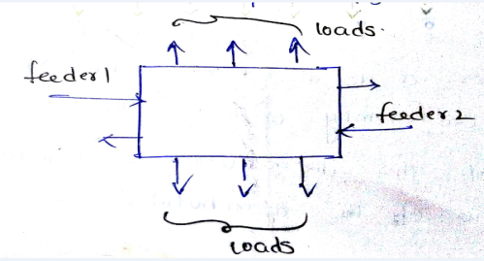

It is considered as a series of open distributors fed at both the ends. The equivalent circuit of above distributor is given as,

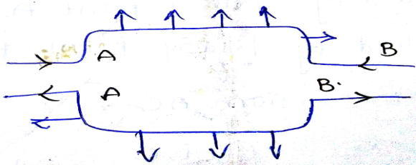

The principle advantage of ring distributor is that by proper choice in number of feeding points, great economy in copper can be achieved.

Ring distributor with interconnectios:

In order to reduce the voltage drops in various sections of the ring distributor’s (which serves a large area) distant points, the distributors are joined through a conductor called interconnector.

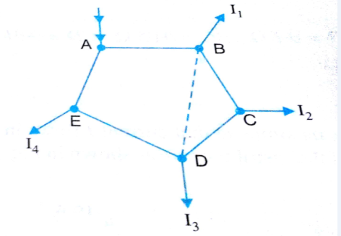

There are several methods for solving these type of problems. One of the method is to apply thevinen’s theorem. The steps involved in this method are:

i) Consider the interconnector to be disconnected. And find the potential difference between the two feeding points. Let this be E0.

ii) Calculate the resistance viewed from the two feeding points ( across which interconnector isconnected) and let it be R0

iii) Then Current in interconnector is given by, 

Therefore the current distribution in each section and voltage of load points can be calculated.

**Stepped and tapered mains**:

A distributor whose cross sectional area at different parts is selected such that the total volume of copper utilized for a given constant voltage drop is called stepped distributor.

Consider a distributor feeding two loads I1, I2 tapped of at points A and B as shown in figure.

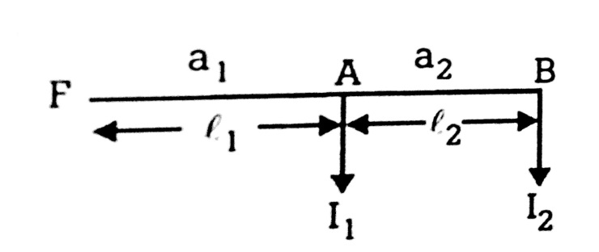

Let a1, l1 and a2, l2 be the area of cross section and lengths of sections FA and AB respectively.

Let  be the resistivity of distributor then,

Resistance for section FA (both go and return) = 

Resistance for section AB (both go and return) = 

Voltage drop in section FA = 

Voltage drop in section AB = 

Where vtis the total voltage drop in the distributor which is constant

Total voltage drop in the distributor ,vt= 

Total volume of the copper = 2a1l1 + 2a2l2 = 

For minimum volume of copper, = 0



Simplifying the above equation, we get,



i.e for minimum volume of copper, the area of cross section of the distributor should be proportional to the square root of the current carried by that part of the distributor which is practically not feasible because more joints are involved which is technically undesirable. One more objection of this method is that future additions to the system may completely alter the distribution of current in sections, and sometimes it is useless to use stepped distributor though it is economical.

A.C. Distribution:

Now a days, electrical energy is generated, transmitted and distributed in the form of alternating current. The energy is transmitted with 3-phase and 3-wire system where as the distribution system is divided into two parts. 1. Primary distribution system: It is 3-phase and 3 wire system which operates at high voltages (3.3, 6.6 or 11KV) than the normal utilization levels. It delivers power to secondary distribution circuit through distribution transformer.

2. Secondary distribution system: Delivers power to various consumers at 400V supply. It consists of 3-phase and 4-wire system for unbalanced load or single phase, 2- wire system for small power appliances.

**Difference between AC and DC distribution systems:**

|  |  |
| --- | --- |
| **DC transmission/Distribution** | **AC transmission/distribution** |
| Required less number of conductors. So less cost | Required more number of conductors. So more cost |
| No L & C effect ⇒ no phase displacement | Construction of line is difficult |
| Less voltage drop. So better voltage regulation | More voltage drop. |
| No skin effect | Skin effect exists |
| No corona loss | Corona loss exists |
| No charging capacitance ⇒ No power loss due to charging capacitor | Power loss due to charging capacitor exists. |
| No dielectric losses | Easy and cheap maintenance is possible |
| No stability problems. | Step up / step down of voltage is possible with transformers |
| Less insulation stress |  |
| No step up / step down of voltage is possible with transformers |  |
| DC switches and Circuit breakers are complex equipment and have less efficiency. |  |

While doing voltage drop calculations in AC distribution system, the following factors to be considered.

i) All the operations (ex: summing or subtracting currents) shoud be done vectorially but not arithmetically.

ii) Power factor of loads should be considered.

There are two ways in referring power factors.

a) Referred to supply or receiving end voltage,

b) Referred to voltage at the load point itself.